**Exploring Weather Trends Project**

Since I am a Chinese student, and my hometown is Nanjing, I prefer to investigate the moving average temperature of China, especially Nanjing.

**Extract the data Using SQL**

select * from global_data;

This query is to select every data for the year vs. global temperature.

select * from city_data

where country = 'China';

This query is to pick up the row where the country of these row in China.

select * from city_data

where city = 'Nanjing';

This query is to choose the data where the city is Nanjing

**Create a line chart**

I just learn the tableau, so I try to use tableau to explore the dataset. First of all, the average temperature is increasingly low when the latitude is higher or farther away from the sea.

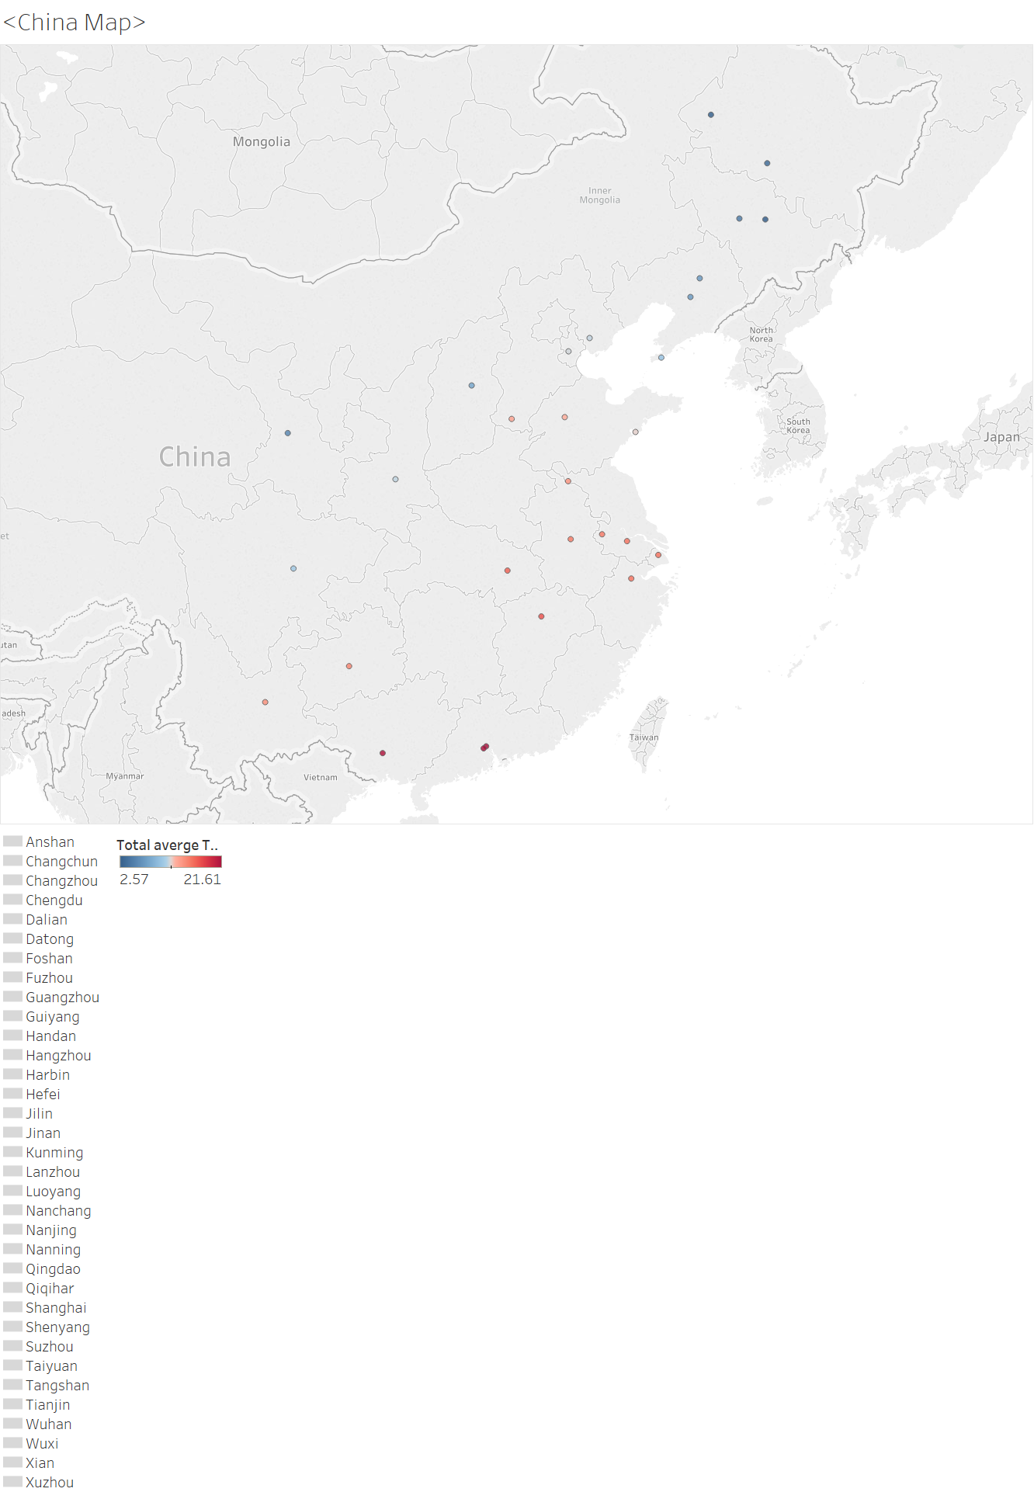

Secondly, I check several cities’ average temperature tend in China. It seems that these cities share similar trends. Nanning and Guangzhou have a higher average temperature than Nanjing. Jilin has a lower average temperature than Nanjing. Nanjing, Suzhou, Shanghai, and Zhenjiang are close to each other. These cities have similar average temperatures.

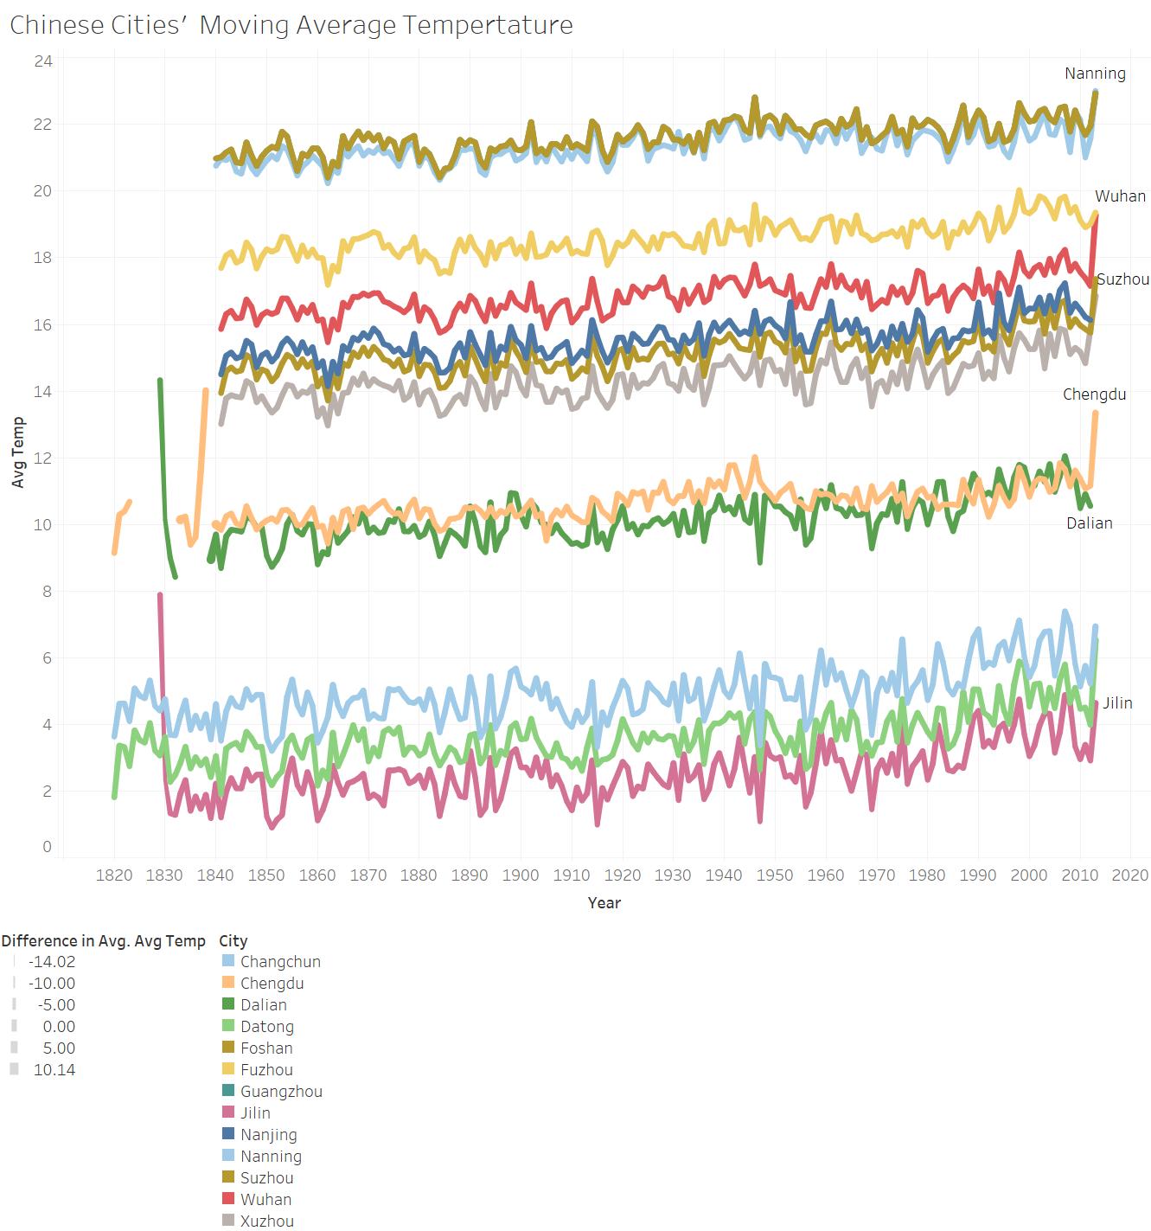

Then, I draw the line plot of Nanjing average temperature and Global average temperature. It shows that Nanjing’s temperature is around 7 degrees C higher than the global average.

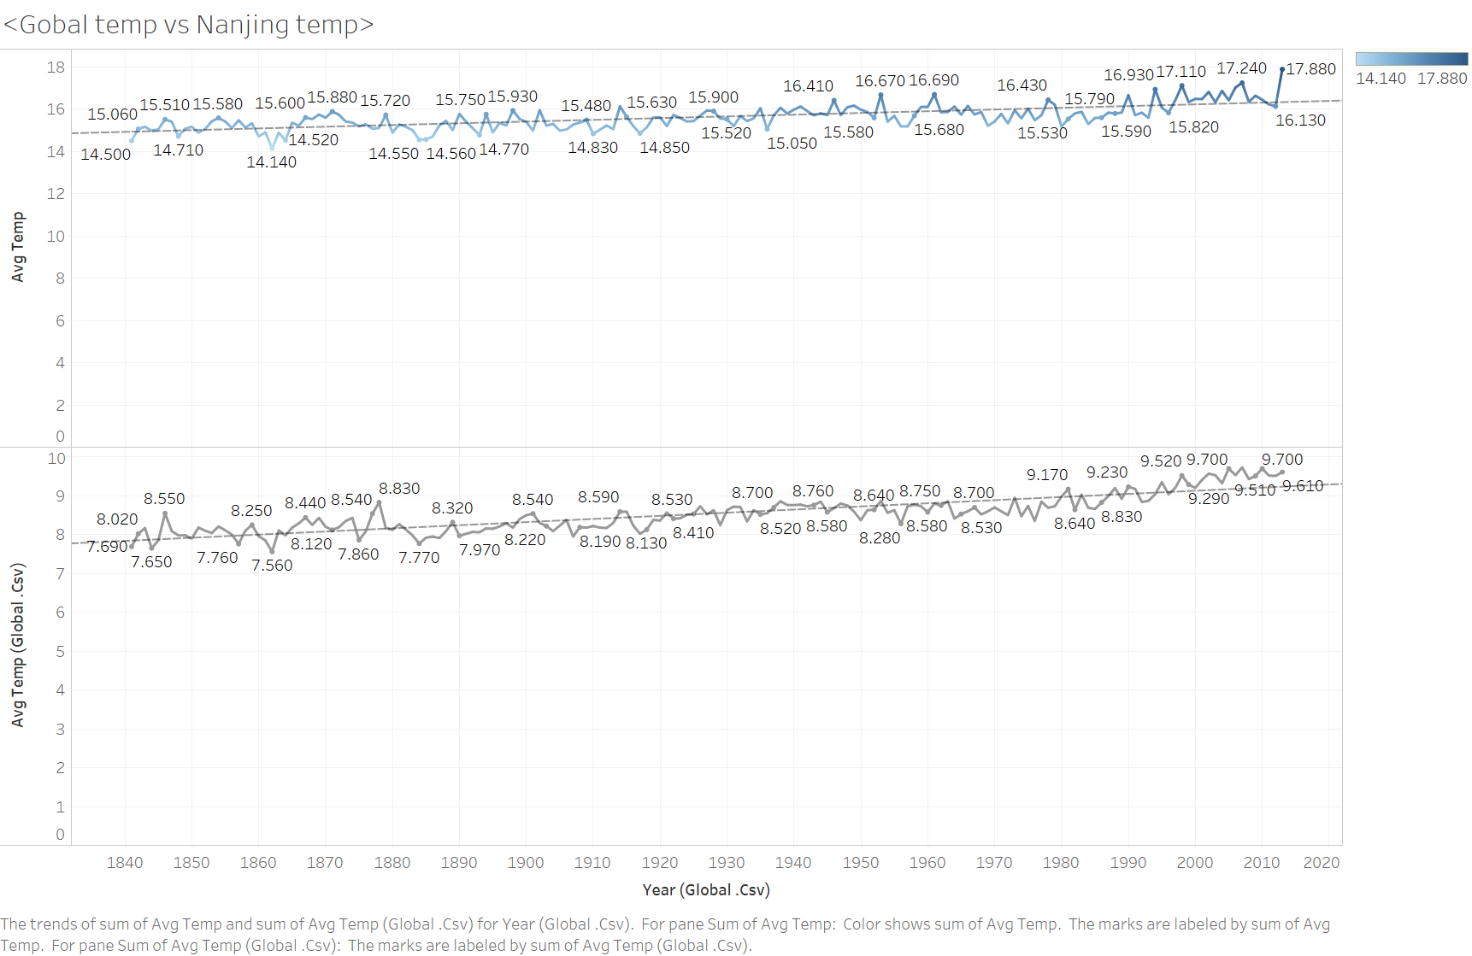

I use the excel to calculate the correlation between global average temperature and Nanjing average temperature. The correlation is 0.79095. The predictive trend line is y = 0.9762x + 7.2803, with R^2 is equal to 0.6256.

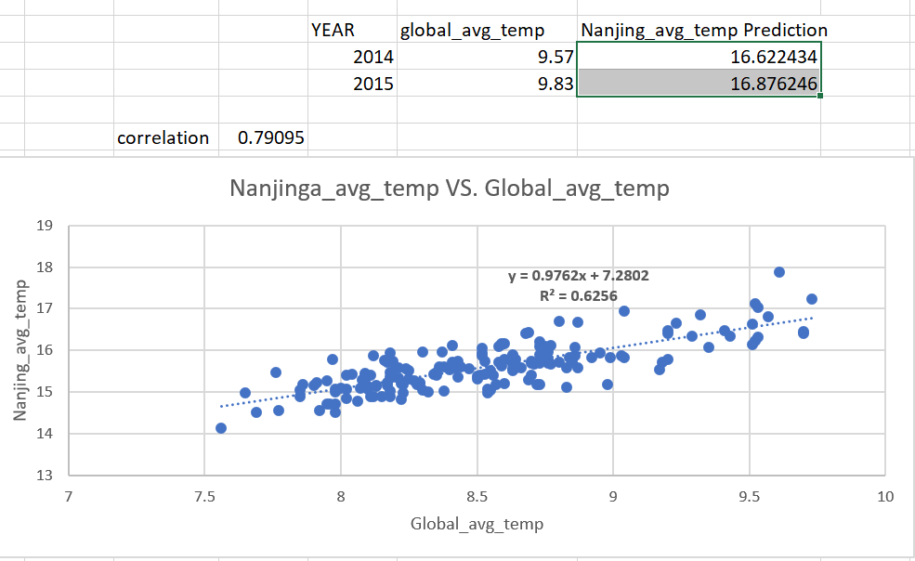

I use the predictive trend line to calculate the Nanjing average temperature for 2014, and 2015, which are 16.622434℃ and 16.876246℃.

To smooth out data, I used the moving average of temperature with 10 years interval. This graph is using the Nanjing Temperature vs Global average temperature. We got a higher square error for trending line since we use a 10 years moving average.

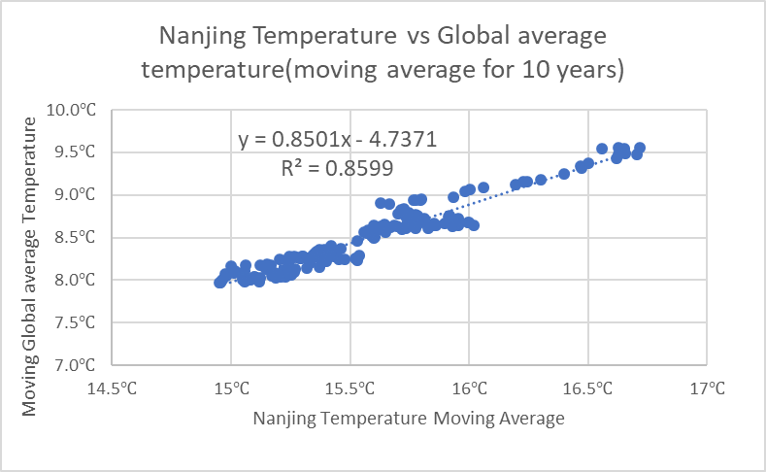

The graph for 10 years moving average temperature for Nanjing’s and Global temperature. Nanjing’s temperature is 7 degree C higher than Global.

